Name: Class:
Introduction
Nano-sized particles are difficult to imagine. This worksheet aims to help you visualise the relative sizes of particles, from the ‘everyday’ size of 1 m, to the ‘nanoworld’ size of 10^{–9} m.
The different sizes of some objects ranging from large to very small are given on the chart below.
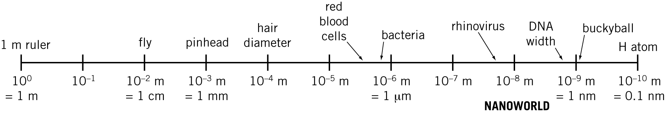

No. | Question | Answer
Complete the table below by listing an object for each size range. For each object listed, state the approximate size, and convert the size to a figure in nanometres. Three examples have been completed for you.
Size range (m) | Object | Object size | Object size (nm)
10⁰ to 10^{–1} | 1-metre ruler | 1.0 m | 1 000 000 000
10^{–1} to 10^{–2}
10^{–2} to 10^{–3}
10^{–3} to 10^{–4}
10^{–4} to 10^{–5}
10^{–5} to 10^{–6}
10^{–6} to 10^{–7} | Mitochondrion | Length 0.5 μm | 500
10^{–7} to 10^{–8}
10^{–8} to 10^{–9}
10^{–9} to 10^{–10} | Copper atom | Diameter 260 pm | 0.260

 | Nanotechnology deals with particles in the size range between 1 and 100 nm. Which of your listed objects would be studied in nanotechnology?
 | A flea has a length of approximately 6 mm. In order to be placed in the realm of nanotechnology, by what factor would this size need to be decreased?
 | The diameter of a hydrogen atom is close to 2.5 × 10^{–10} m. In order to be placed in the realm of nanotechnology, by what factor would this size need to be increased?
Suppose you were to use a length of paper tape to make a scale on which to represent the relative sizes of objects. If 1 cm of tape represented 1 nm, what length of tape would be required to represent:
a the 2 μm length of an E. coli bacterium?
b the 330 mm length of a textbook?

